OS Lab Tasks
Task 1:
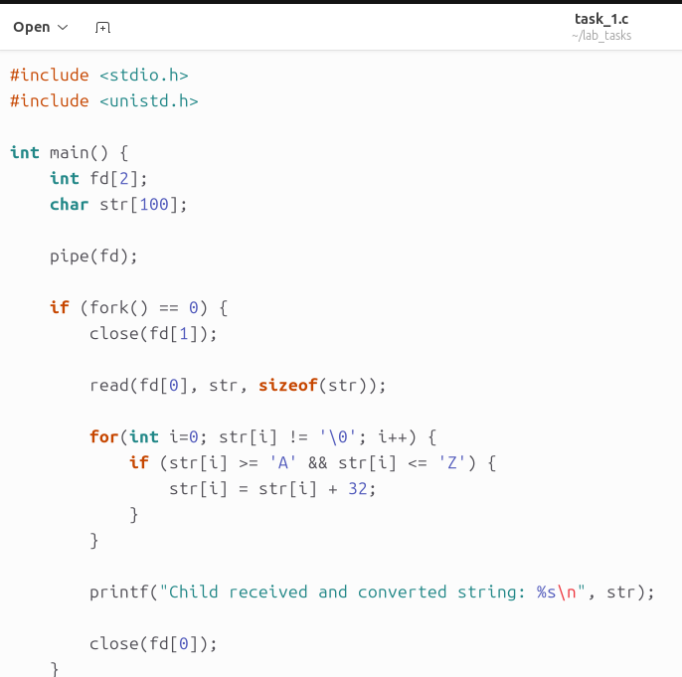
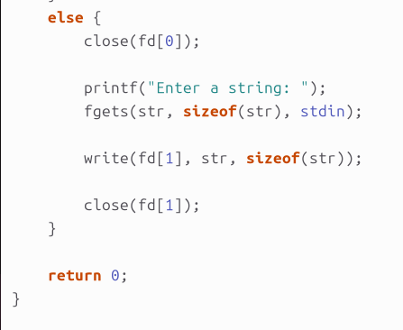
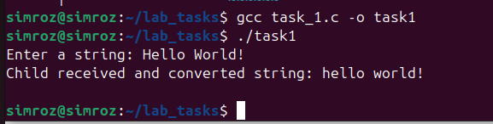

Task 2:
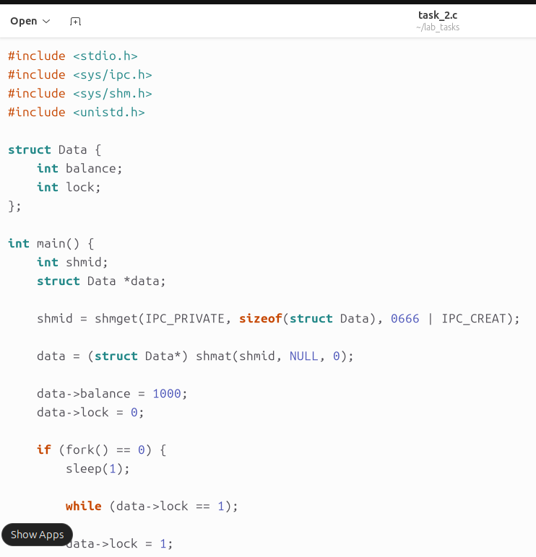
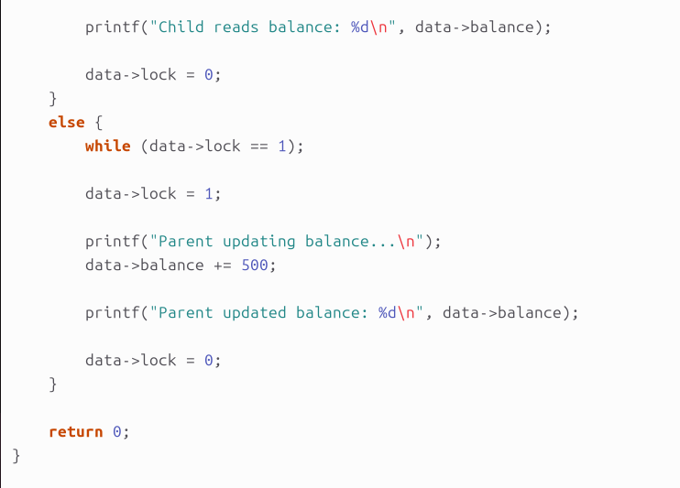
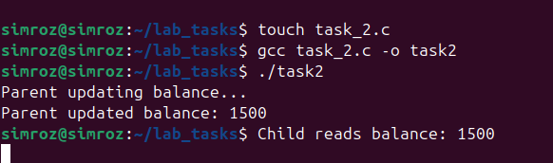
How it maintains consistency:
- Shared Memory:
- Both processes access the same balance variable directly.
- Lock Variable (lock):
- Acts like a simple mutex:
  - 0 → free
  - 1 → in use
- Mutual Exclusion:
- Before accessing balance, a process:
  - waits until lock == 0
  - sets lock = 1 (enters critical section)
- After finishing:
  - sets lock = 0 (releases access)
- Prevents Race Conditions:
- Ensures:
  - Writer doesn’t update while reader is reading
  - Reader doesn’t read partial updates
Task 3:
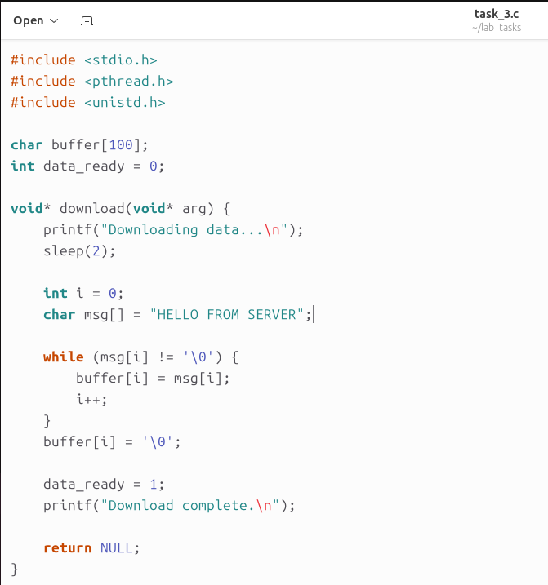
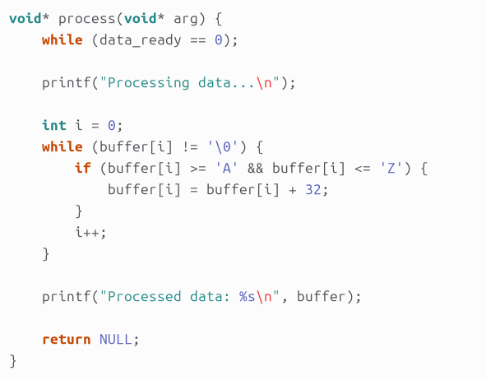
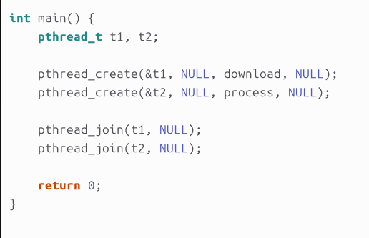
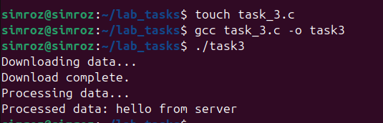

Task 4:
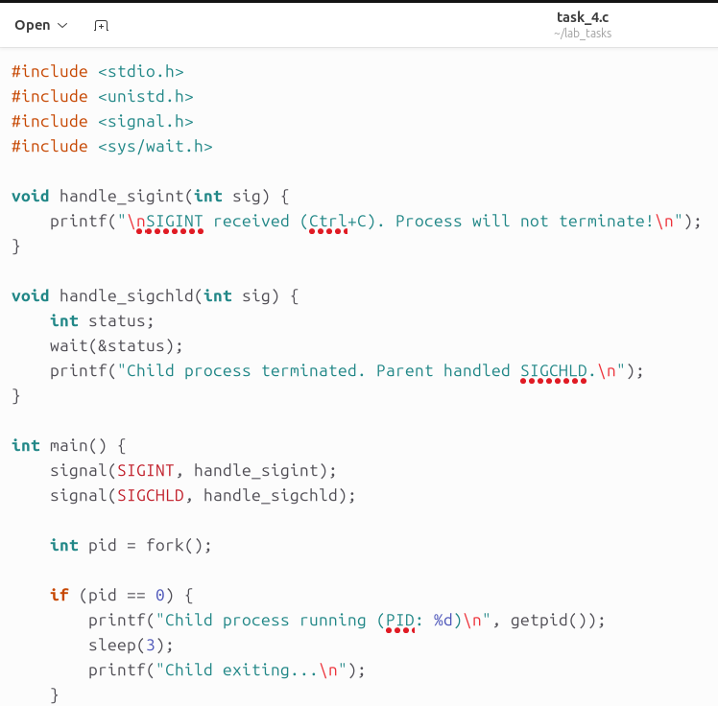
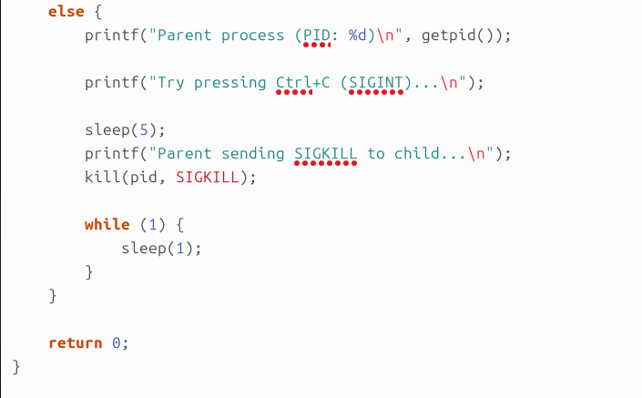
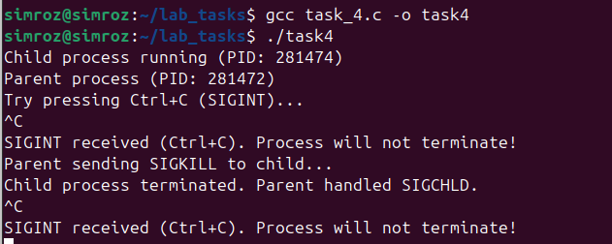

Task 5:
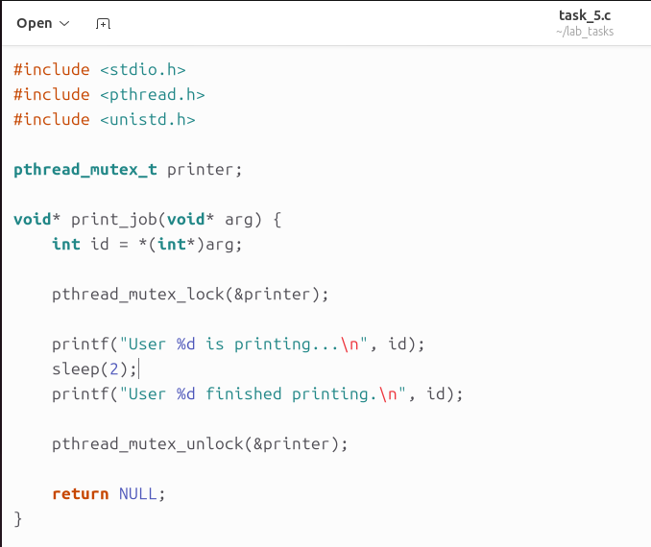
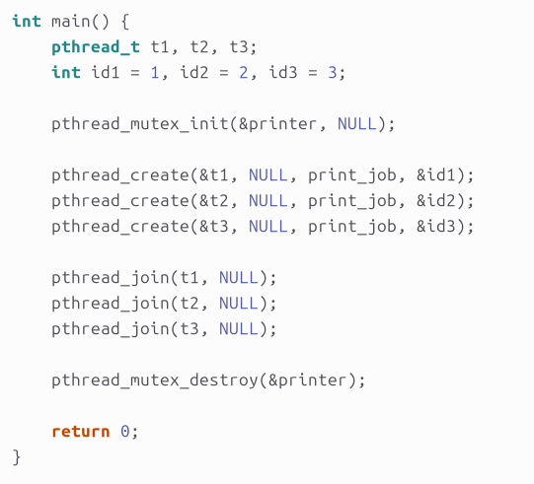
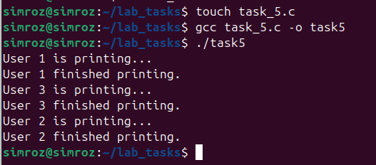
How synchronization prevents race condition:
Without Mutex (Problem)
Two users access printer at same time and Output overlaps → corruption occurs.
With Mutex:
Only ONE thread enters critical section (printer use) and Threads wait in queue and printer is used one-by-one.

